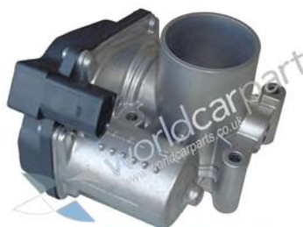

Admission controller

# Introduction

This work will be developed to ATLASCAR 1 and to substitute the actual admission controller for a new one more stable.

The actual controller has some difficulties to repeat the same position. Is easily observed this when the car is starting to move, where a routine is executed to achieve a specified rpm in the engine, but this rpm value is quite different for the same requested position.

# New approach

The new approach will pass by readapt a position controller of a common RC servo to control in position the throttle. The new ECU system is composed by two boards, one is the RC servo control and the second is a board with a microcontroller that will be the interface with ADA system and human driver.

|  |
| --- |
| **ECU**  **Interface Board ACADM**  **Servo Position controller** |

## Main Cycle

The new ECU will run a cycle where she will be in charge of do some activities. The must be able to do:

* Read throttle position at each cycle
* Read ADA driver new admission value
* Read human driver new admission value
* Set motor position according new values

|  |
| --- |
| Read throttle position  Init ECU  Read pedal position  Read ADA position  Man?  Calculate new potentiometers values  Send calculated values  Calculate PWM  New pos?  Set PWM |